William Mackay
MTH 337, Professor Adam Cunningham

Weekly Report 04
Introduction
In this report, the features of Numpy, a scientific computing package for Python, and the details of floating point arithmetic were explored. Knowledge of both Numpy and floating point operations is important in scientific and mathematical computing, especially in Python. Numpy has a great deal of features that make writing mathematical models and simulations more efficient and intuitive, and will be used often in upcoming assignments. The limits and precision of floating point operations are also large factors in the implementation of mathematical models in Python. If not accounted for properly, errors in floating point arithmetic can compound and cause software to function improperly.
Approach
For the first part of this assignment, NASA weather balloon data had to be loaded and plotted using Numpy. This was done using numpy.loadtxt, which, when given a file name and the number of rows to skip, loads values from a text file and stores them in an array. This function can be used with files of many different types, including .txt and .dat. The time data from the NASA file was represented in minutes and seconds, initially. These minute and second values had to be converted to a single floating point time value in minutes before they could be plotted. This was done by using the formula, where m is the number of minutes and s is the number of seconds. For example using this formula, 1 minute and 30 seconds would become 1.5 minutes. Once the time data were converted, the temperature data were plotted against time and analyzed.
In order to better understand the way in which floating point arithmetic is performed, several quantities needed to be found through experimentation. The first was machine epsilon, or the smallest number that can be added to 1 such that 1+ε ≠ 1. This was found by raising 2 to more and more negative exponents and adding the result to 1 until the condition 1+ε ≠ 1 was no longer satisfied. The next was the smallest number that could be expressed using floating point representation. This was done by raising 2 to more and more negative exponents until the number found from the previous iteration was the same as the number found in the current iteration. This was done because once the smallest floating point number has been found, any attempts to represent a smaller number would result in the smallest number. Finding the largest number that could be expressed using floating point notation was more difficult, because denormalization prevents underflow errors, but not overflow errors. During the experiments that were performed to find the largest floating point number, the code would often overshoot the value, resulting in overflows. In order to mitigate this problem, the try and except commands were used so that if an overflow error occurred, the previous iterations value could be returned. Logically, the largest value that could be expressed before running into an overflow error would be, or be close to, the largest floating point number. Once these numbers were found, the number of bits reserved for the exponent and mantissa components of a floating point number were possible to calculate.
Results
Once the NASA temperature data were loaded and plotted, the Figure 1 was obtained.
The machine epsilon obtained through the experiments was 2.22044604925•10⁻¹⁶. The smallest value that could be expressed using floating point format that was found using Python was 4.94065645841•10⁻³²⁴. The largest floating point value that could be represented was found to be
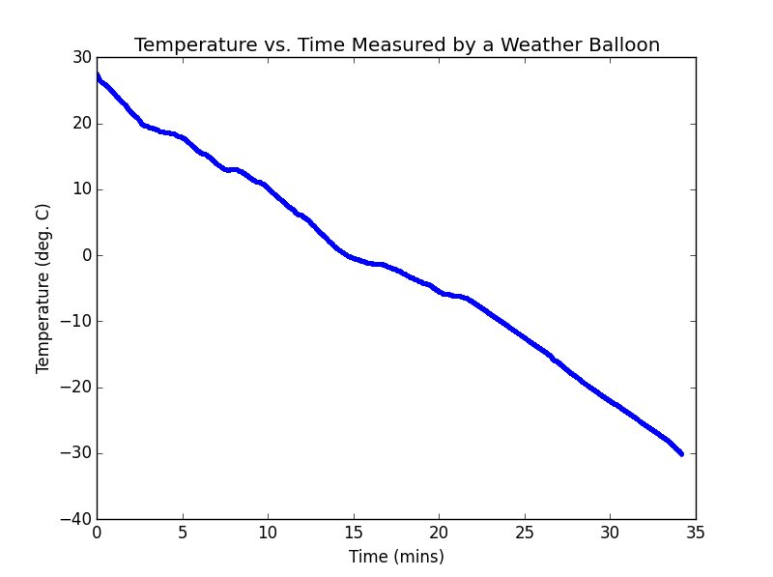Figure 1
Conclusion
From the temperature vs. time plot in figure 1, it can be seen that temperature decreases as altitude increases. As the flight of the weather balloon progressed and the altitude of the balloon increased, temperature decreased almost linearly. If it is assumed that the balloon ascended at a constant velocity during its flight, then the temperature can be assumed to be indirectly proportional to altitude.
From the values found for the smallest and largest values that can be represented using floating point notation, it is possible to find the number of bits reserved for the exponent and mantissa of a 64-bit floating point number, as well as the bias used so that negative exponents can be expressed without needing an extra sign bit. Floating point numbers follow a specific format, which includes a signed number multiplied by 2 raised to an exponent. The leading number and the exponent are expressed in binary so that the number can be expressed in bits. The leading number is also assumed to have a leading digit of 1 in most cases. One of the bits is reserved to designate the sign of the number and 3 special cases are reserved for 0, infinity, and not-a-number. Because denormalization is used for small numbers, effectively increasing the range of very numbers that can be expressed, it would not be best to use the smallest value's exponent to find the number of bits reserved for the exponent. Denomalization increases this range by creating special cases for small numbers where the leading digit in front of a floating point number is assumed to be 0 instead of 1. Using the largest floating point value's exponent of 10, it was possible to calculate the largest exponent of 2 in floating point notation. By solving the equation 10³⁰⁸=2^{x} for x, the exponent of 2 was found to be approximately 1023, which, in binary, is 01111111111. This number requires only 10 digits in binary, but because of the special case reserved for infinity, this value would actually have a maximum of 1024, which requires 11 bits. Because the number of exponent and sign bits are known, the number of mantissa bits would be the number of remaining bits. Since there are 64 bits in a floating point number, with 11 exponent bits and 1 sign bit, there will be 52 bits reserved for the mantissa. The bias applied to the exponent must make the range of exponents approximately symmetrical. Since there are 11 exponent bits, the range of exponents goes from 0 to 2048. In order for this range to be evenly spit between positive and negative exponents, the bias would have to be -1024, but because of the special cases for 0 and infinity, that bias becomes -1023.
Python Code
#William Mackay
#MTH 337 Assignment 04

from pylab import *

#Part 1- Loading and Plotting Weather Balloon Data
data=loadtxt("balloon.dat", skiprows=138)
mins=data[:,0]
secs=data[:,1]
t=mins+(secs/60)
temp=data[:,5]

plot(t,temp,'b.')
xlabel('Time (mins)')
ylabel('Temperature (deg. C)')
title('Temperature vs. Time Measured by a Weather Balloon')

#Part 2- Finding machine epsilon, maximum float, and minimum float
def find_epsilon():
n=0
while True:
x=2**(-n)
if 1+x!=1:
n+=1
else:
return 2**-(n-1)
def max_float():
n=1.
x=2.
count=0
while True:
try: y=x**n
except:
return x**(n-0.0005)
break
n+=0.0005

def min_float():
n=1.
x=2.
while True:
y=x**n
#print '%e' % y
if y==x**(n+1):
return y
else:
n-=0.015

epsilon=find_epsilon()
minFloat=min_float()
maxFloat=max_float()

print 'Machine epsilon is',epsilon
print 'The smallest floating point number is', minFloat
print 'The largest floating point number is', maxFloat

show()

